

**Changsha University of Science and Technology**

School of Computer and Communications Engineering Experiment Course for Python Programming

# Course Name: Python ProgrammingGrade: 2021 Fall Major: Computer Science and Technology

# Student ID: Gj2021009135 Chinese Name: **莫森**

# Name: Munasinghe Munagamage Don Ashan Dinisuru

# Date: 21/03/2024

**(1) Calculate the average fuel consumption of the vehicle**

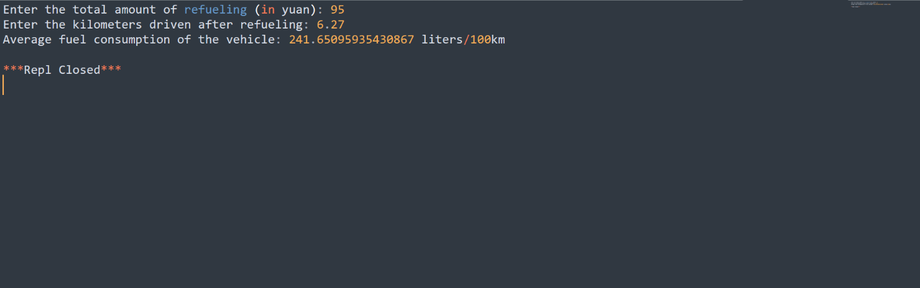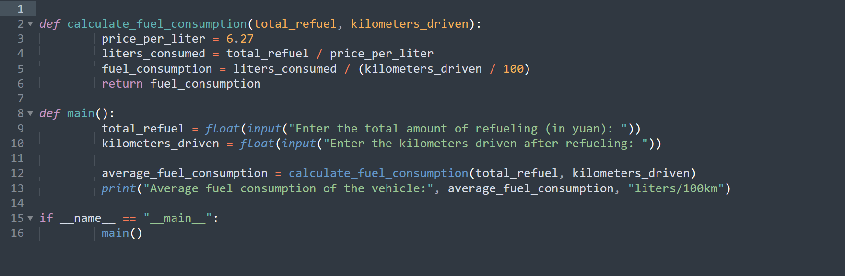Xiaoke's recent car odometer shows that the fuel consumption of 100 kilometers is much lower than usual. He suspects that the data is inaccurate. Please help him write a program to input the total amount of refueling and the kilometers of running after refueling to calculate the fuel consumption of the vehicle (assuming that 95 gasoline is used, the average price is 6.27 yuan)

**(2) Conversion from Fahrenheit to Celsius**

The temperature in our country is expressed in Celsius, while the temperature in Fahrenheit is widely used in other English speaking countries such as Western Europe, the United Kingdom and the United States. The formula for converting Fahrenheit to Celsius is C=(F-32)*5/9, while the formula for converting Celsius to Fahrenheit is F=(C*9/5)+32. Please write a program to convert the Fahrenheit temperature entered by the user into Celsius temperature (keep an integer)

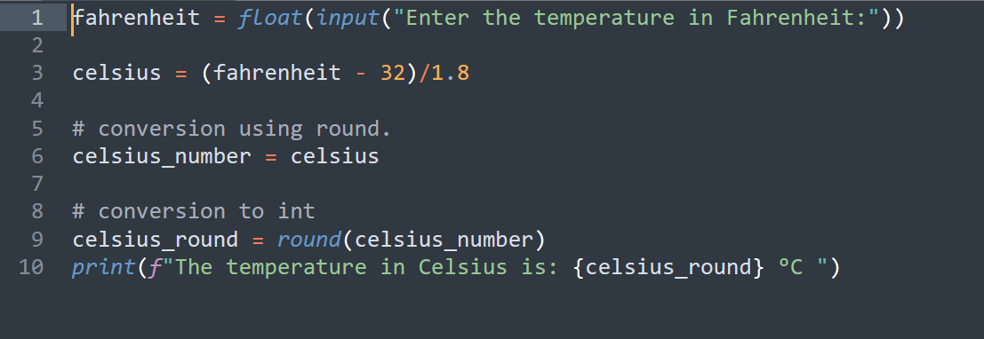

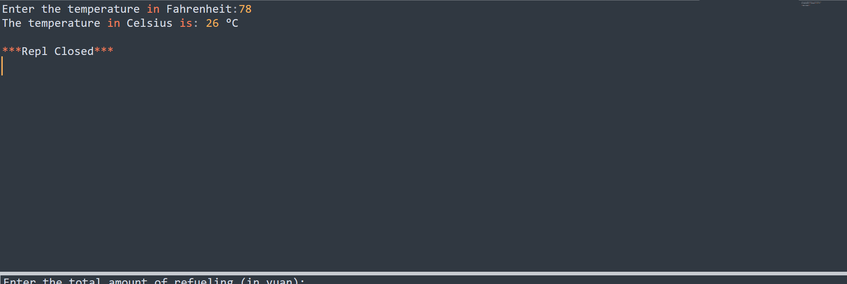

**(3) Generate numbers from the digits**

With 1, 2, 3, and 4 numbers, how many three-digit numbers can be formed without repeating numbers? How much are each?

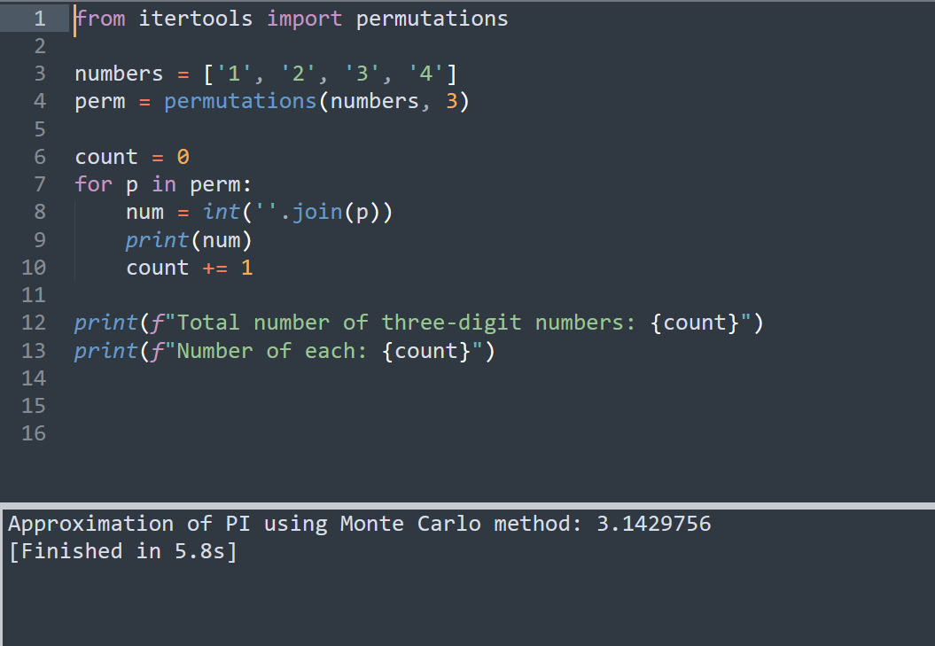

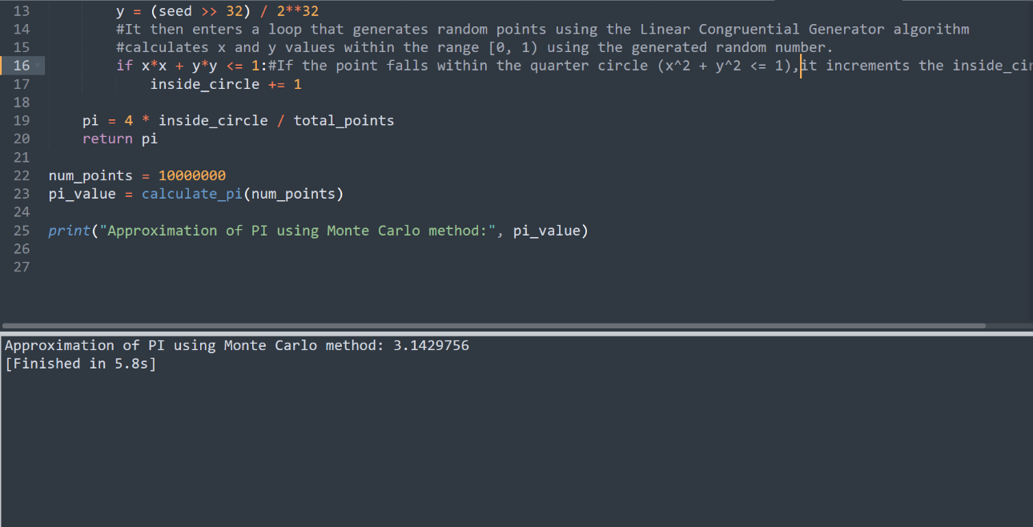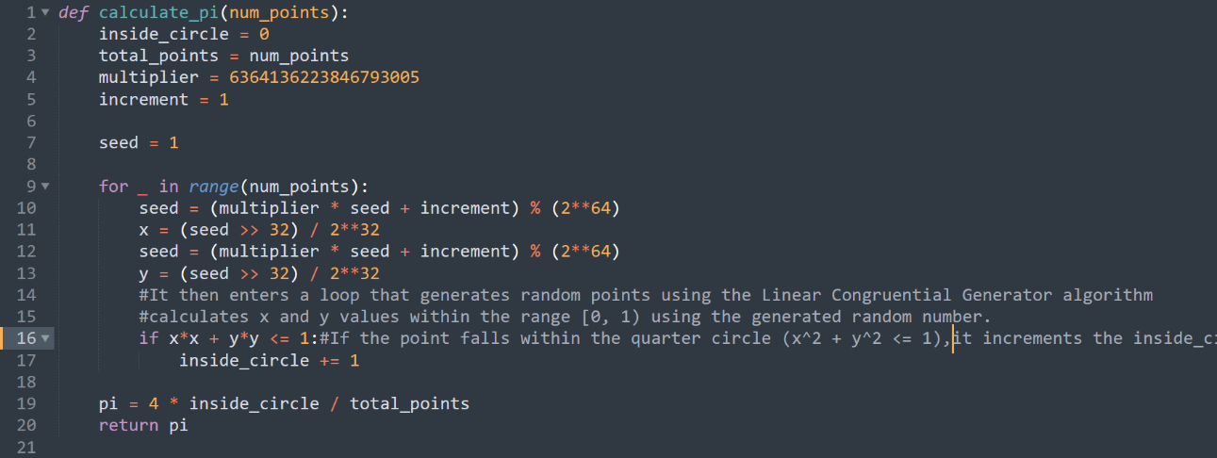**(4) Calculate the PI by using the Monte Carlo method**